2nd Semester, AY 2021-2022

**IT 6203- Database Management System II**

**Activity**

**PART I.**

1. Company Product

CREATE TABLE public."Total" (users varchar(255), sum_of_the_cart numeric);

ALTER TABLE IF EXISTS public."Total"

OWNER to postgres;

INSERT INTO "Total" ("users", "sum_of_the_cart")

VALUES ('Jinx', '2536');

CREATE VIEW user_total AS SELECT "users", "sum_of_the_cart"

FROM "Total";

SELECT * FROM user_total;



1. User Total

CREATE TABLE public."Item" (product_name varchar (255), price numeric,

average_rating numeric, count_of_reviews numeric);

ALTER TABLE IF EXISTS public. "Item"

OWNER to postgres;

INSERT INTO "Item" ("product_name", "price", "average_rating", "count_of_reviews")

VALUES ('Gucci Bag', '25000', '10', '2032');

CREATE VIEW company_product AS SELECT "product_name", "price", "average_rating",

"count_of_reviews"

FROM "Item";

SELECT * FROM company_product;



1. Annual Orders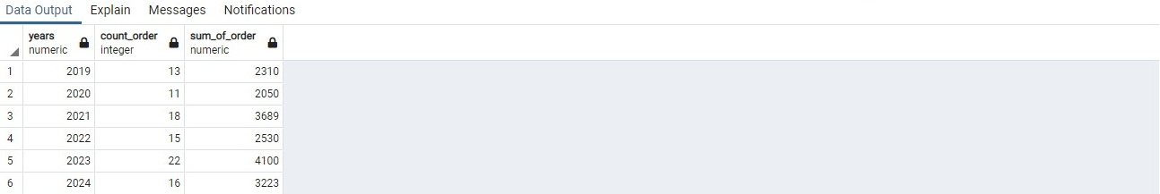

CREATE TABLE public."Yearly_Orders" (years numeric, count_order int, sum_of_order numeric);

ALTER TABLE IF EXISTS public. "Yearly_Orders"

OWNER to postgres;

INSERT INTO "Yearly_Orders" ("years", "count_order", "sum_of_order")

VALUES ('2019', '13', '2310');

INSERT INTO "Yearly_Orders" ("years", "count_order", "sum_of_order")

VALUES ('2020', '11', '2050');

INSERT INTO "Yearly_Orders" ("years", "count_order", "sum_of_order")

VALUES ('2021', '18', '3689');

INSERT INTO "Yearly_Orders" ("years", "count_order", "sum_of_order")

VALUES ('2022', '15', '2530');

INSERT INTO "Yearly_Orders" ("years", "count_order", "sum_of_order")

VALUES ('2023', '22', '4100');

INSERT INTO "Yearly_Orders" ("years", "count_order", "sum_of_order")

VALUES ('2024', '16', '3223');

CREATE VIEW count_year AS SELECT "years", "count_order", "sum_of_order"

FROM "Yearly_Orders";

SELECT * FROM count_year

1. New User 

CREATE TABLE public."New_User" (userID int, Username varchar(255), Email varchar(255), Date_of_creation

date);

ALTER TABLE IF EXISTS public. "New_User"

OWNER to postgres;

INSERT INTO "New_User" ("userid", "username", "email", "date_of_creation")

VALUES ('20937465', 'Juzu', 'Juzumix67@gearup.com', '2015-06-25');

INSERT INTO "New_User" ("userid", "username", "email", "date_of_creation")

VALUES ('20933812', 'TsuKei', 'TsukishimaKei@noble.com', '2016-09-24');

CREATE VIEW newuser AS SELECT "userid", "username", "email", "date_of_creation"

FROM "New_User";

SELECT * FROM newuser

1. Banned User. 

CREATE TABLE public."Banned_Users" (userID int, Date_banned date, Date_until_unbanned

date);

ALTER TABLE IF EXISTS public. "Banned_Users"

OWNER to postgres;

INSERT INTO "Banned_Users"("userid", "date_banned", "date_until_unbanned")

VALUES ('23901237', '03-26-2017', '09-11-2030');

INSERT INTO "Banned_Users"("userid", "date_banned", "date_until_unbanned")

VALUES ('23903421', '04-29-2020', '06-13-2020');

CREATE VIEW banned_user AS SELECT "userid", "date_banned", "date_until_unbanned"

FROM "Banned_Users";

SELECT * FROM banned_user

1. Discounted (Sale)

CREATE TABLE public."Sales_Discount" (product_name varchar(255), sale_discounted numeric, original_price numeric,

discounted_price numeric);

ALTER TABLE IF EXISTS public. "Sales_Discount"

OWNER to postgres;

INSERT INTO "Sales_Discount" ("product_name", "sale_discounted", "original_price", "discounted_price")

VALUES ('Shoes', '750', '2500', '1750');

INSERT INTO "Sales_Discount" ("product_name", "sale_discounted", "original_price", "discounted_price")

VALUES ('Sandals', '25', '125', '100');

CREATE VIEW sale AS SELECT "product_name", "sale_discounted", "original_price", "discounted_price"

FROM "Sales_Discount";

SELECT * FROM sale

ORDER BY "sale_discounted" DESC, "discounted_price" DESC

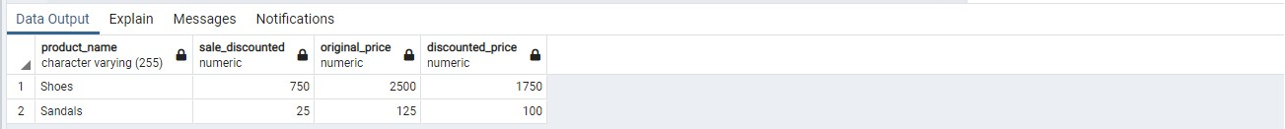

1. Deletes Users 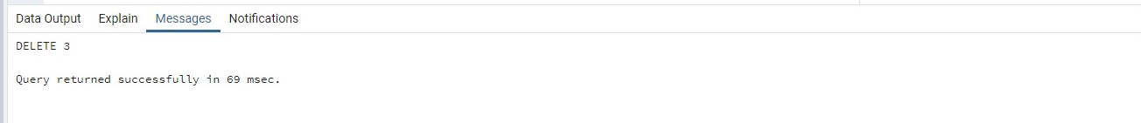

CREATE TABLE "Permanently_Deleted" (user_id int, firstname varchar(255), lastname varchar(255));

ALTER TABLE IF EXISTS public. "Permanently_Deleted"

OWNER to postgres;

INSERT INTO "Permanently_Deleted" ("user_id", "firstname", "lastname")

VALUES ('2084','Kenshin', 'Sun%');

INSERT INTO "Permanently_Deleted" ("user_id", "firstname", "lastname")

VALUES ('2085','Mario', 'Luigi!');

INSERT INTO "Permanently_Deleted" ("user_id", "firstname", "lastname")

VALUES ('2086','Dragon', 'Monkey');

DELETE FROM "Permanently_Deleted" WHERE firstname Like '%@%';

DELETE FROM "Permanently_Deleted" WHERE firstname Like '%%%';

1. Cart

CREATE TABLE public."Cart"(user_ID int, user_fullname varchar(255), product_id int, product_name

varchar(255),

product_price numeric, product_discount numeric,

product_original_price numeric, product_discounted_price numeric,

product_vendorid int, product_vendor_name varchar(255),

quantity numeric, subtotal numeric);

ALTER TABLE IF EXISTS public. "Cart"

OWNER to postgres;

INSERT INTO "Cart" ("user_id", "user_fullname", "product_id", "product_name", "product_price",

"product_discount",

"product_original_price", "product_discounted_price", "product_vendorid",

"product_vendor_name", "quantity","subtotal")

VALUES ('206758','Kamado Tanjiro', '5', 'Shoes', '3500', '1225', '3500', '2275','3', 'Kibutsuji Muzan', '4','9100');

CREATE VIEW cart AS SELECT "user_id" "user_fullname", "product_id", "product_name", "product_price",

"product_discount",

"product_original_price", "product_discounted_price", "product_vendorid",

"product_vendor_name", "quantity","subtotal"

FROM "Cart";

SELECT * FROM cart

